# **Sprint 1 Plan**

Risposta

Lino Le Van, Yiming Zeng, Matthew Macarewich, Nathan Lin, Trevor Gardner, Harrison Zhou

Revision #2

**Sprint 1 Completion Date: 1/30/2024**

## Goal

Have all members of the Risposta team familiarize themselves with the stack that they are unfamiliar with. Go through basic Fresh/Deno/Supabase documentation. We also want to finish the initial setup of Risposta.

## Task List

* As a user, I want to log in [so that I can use the app]

## Team Roles

Lino Le Van - Product Owner

Yiming Zeng - Product Developer

Matthew Macarewich - Product Developer

Trevor Gardner - Product Developer

Harrison Zhou - Product Developer

Nathan Lin - Scrum Master

## Initial Task Assignments

Lino: As a user, I want to log in [so that I can use the app]

Everyone Else: Learn and familiarize themselves with the new stack

Initial Burnup Chart

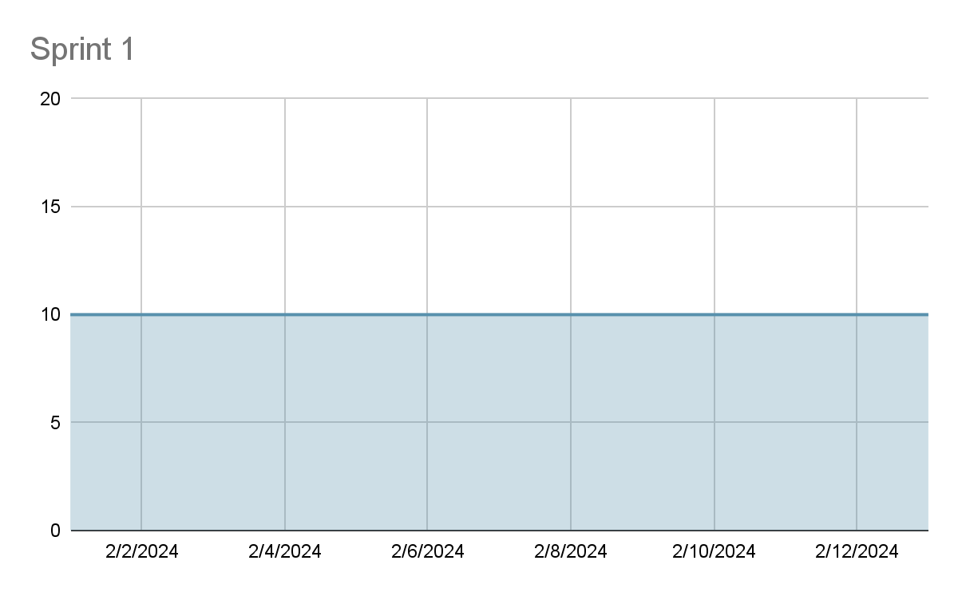

## Initial Scrum Board

<https://trello.com/b/jMbIVKPE/risposta>

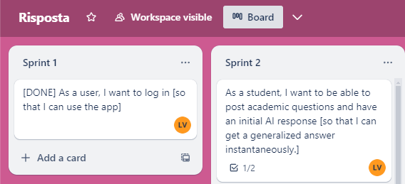

## Scrum Times

We plan to have our scrum meetings M/W/F at 9pm. Our TA meetings will be held on Thursday from 9:30-10:15.